|  |  |  |
| --- | --- | --- |
|  | Add-in Marketplace | |
|  | | |
| PTV’s add-in Marketplace | |  |
| Submit your Add-in Proposal | |  |
|  | |  |
|  | | |
|  | | |
|  | | |
| Karlsruhe, January 2014 | | |

Please fill in some basic information about your add-in and send the form to Traffic.Marketing@ptvgroup.com

1. Name of your add-in

Optimal Count Locator (OCL)

1. Short description

Optimal Count Locator employs acknowledged optimization technique to specify set of optimal counting locations covering as much flow and as many OD pairs as possible. OCL finds links and nodes which should be measured for best efficiency.

1. Description

OCL tells you where to place counting locations in the transport model to get best results.

Our tool employs acknowledged optimization technique to specify set of optimal counting locations catching as much flow and as many OD pairs as possible. OCL is the optimization procedure wrapped in intuitive, user friendly interface, which can quickly find optimal solution even for complex networks.

User can define the budget (number of points that can be counted) and detectors which are already installed. It’s also available to determine what kind of detectors we want to install: junction, link, directed link.

Additional technical parameter is algorithm depth, being number of paths between origin and destination that are taken into calculation process.

We propose various strategies of optimization. In our opinion, and due to our tests, the most useful is mixed maximization of both OD pairs coverage and flow coverage, however you can choose to maximize only flow, or only OD pairs.

Running time depends on size of the network. On the average up-to-date PC it takes about 1 minute to download 300k paths (model for Kraków, Poland of ca. 350 zones), and then time of optimization itself depends on number of connectors and takes roughly 5s per detector.

To see results visually, you can import prepared .gpa file. Additionally you can use our flow bundle generator, where you can clearly see which flows are covered with your detection. For detailed results and statistics you can see report including OD coverage, flow coverage, keys of detected elements, calculation time, etc.

1. Compatibility with software

X PTV Visum

☐ PTV Vissim

☐ PTV Viswalk

1. Compatibility with software release

12, 12.5, 13

List the major releases with which your add-in is compatible. Example: 12.5, 13.

1. Language support

Click if applicable

x English

☐ Chinese

☐ French

☐ German

☐ Spanish

x Others: Polski

1. URL

www.intelligent-infrastructure.eu

1. Tagging

Optimization, Measuring, Count Locations, Detectors,

1. Visualisation

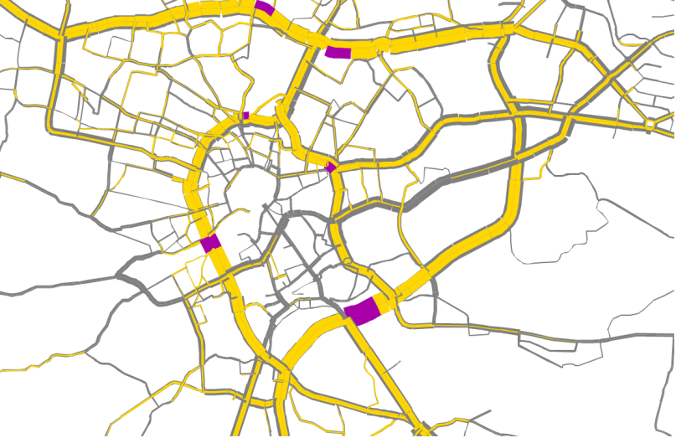

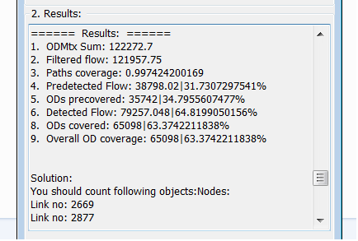

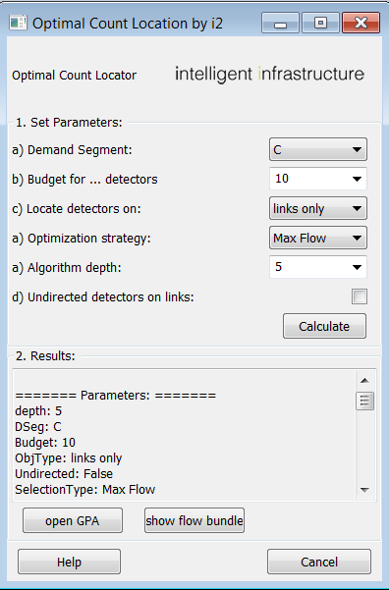



1. Price

1 000 €

Who's working on your add-in? Tell us about the author or company behind this add-in.

1. Name of the company

i2 Intelligent-Infrastructure

1. Primary author

Rafał Kucharski

1. Contributors

Daniele Tiddi

*Please enter the names of any other contributors to this extention

For invoicing your contact details are needed.

☐ Mrs x Mr

☐ Prof. ☐ Dr

First name: Rafał

Last name: Kucharski

Company: i2 Anna Skoczylas

Tax-ID: PL 677 236 16 69

PTV customer number: - (Politechnika Krakowska)

Street: al. Krasińskiego 4/5

Post code: 30-101

Town: Kraków

Country: Polska

Email: info@intelligent-infrastructure.eu

Phone: +48 501 694 896